DATE | 28-02-2026
TEAM ID | LTVIP2026TMIDS89110
PROJECT NAME | plugging into the future: an exploration of electricity consumption patterns using tableau
MAXIMUM MARKS | 4 MARKS

6.4 DASHBOARDS
Dashboard1:
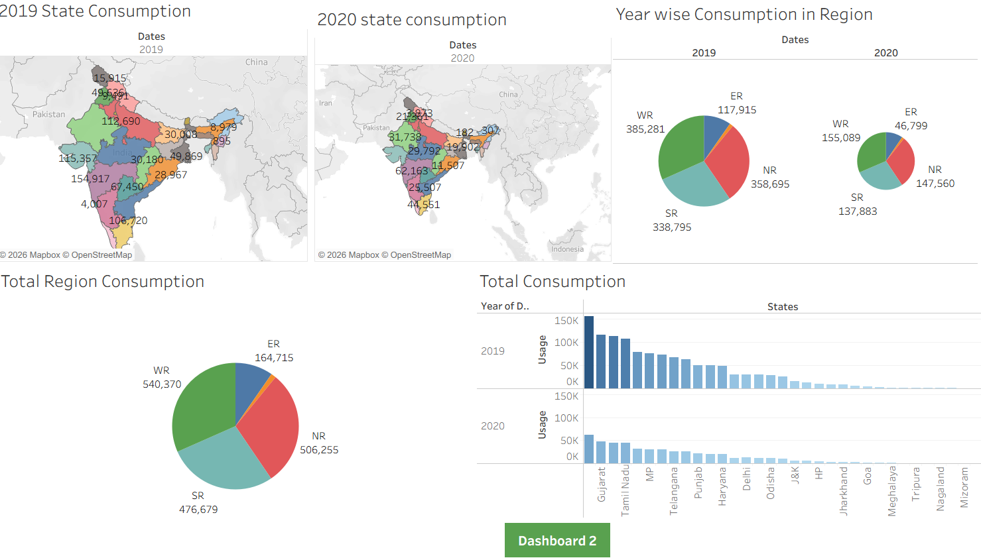

Dashboard2:
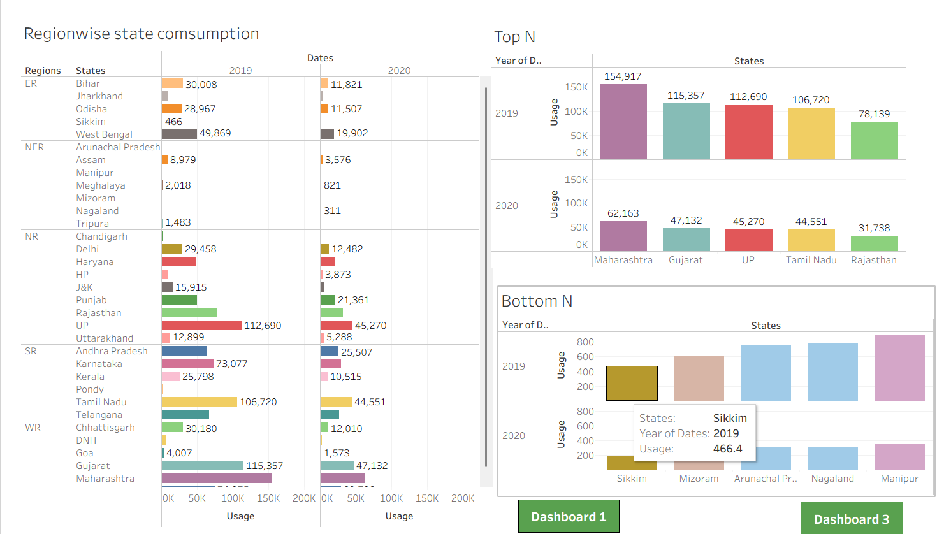
Dashboard3:
